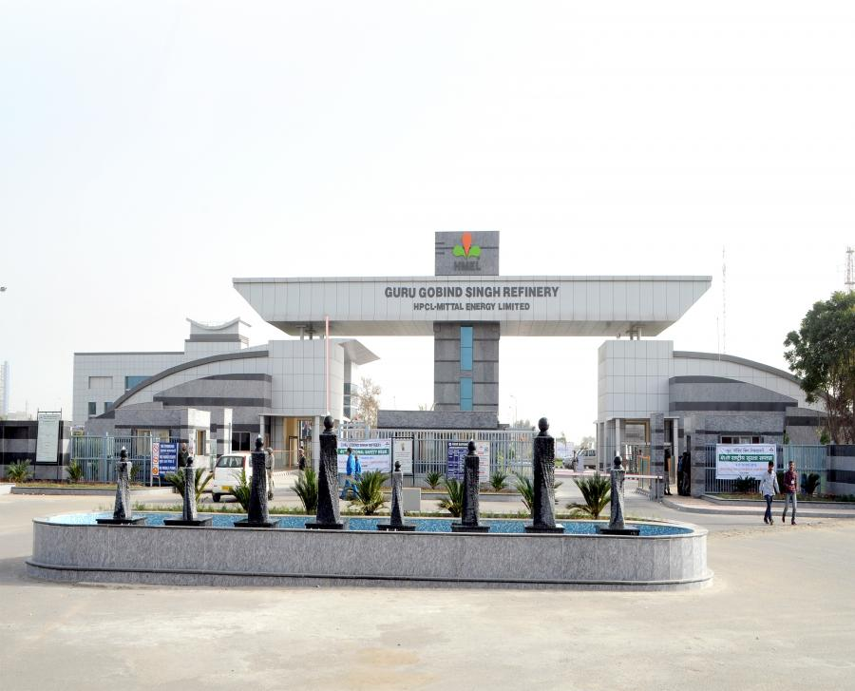

**TRAINING REPORT**

**Internet of Things (IoT) / Industry 4.0, SAP development and Hands-on APM Infrastructure**



# Hindustan Petroleum – Mittal Energy Limited

# Guru Gobind Singh Refinery,

# Bhatinda, Punjab

# Submitted By:

# Jatin Madan

# Vellore Institute of Technology, Vellore

# Table of Contents

# Preface

I, Jatin Madan, a student of Vellore Institute of Technology, Vellore, Tamil Nadu is studying in the Fourth Semester. As a part of the 4-year BTech course, I have undergone a project as a Major Project work on “Internet of Things (IoT) / Industry 4.0, SAP development and Hands-on APM Infrastructure” to facilitate them with the automated software processes and Internet of Things Concept deployment.

Enterprise Resource Planning is that growing segment of Information Technologies that fulfill the needs of the enterprises like Quality, Time to Market, Customer Satisfaction, Performance and Profitability very effectively and efficiently.

The aim of the training was to gets a hand-on experience with the Industry 4.0 infrastructure with all its advantages over the previous Industry X.0 infrastructures. Along with the Usage of ERP System SAP software and learning about all its advantages over the manual systems. All the operations of the company can be integrated.

HMEL has embarked on a journey to implement Strategic Applications like Manufacturing Execution System (MES), SAP, Distributed Control System (DCS), Integrated Security System (ISS) and other refinery and pipeline application to operate a ‘World Class Refinery’. Project Prism is the umbrella program to implement MES, SAP and ISS.

# Acknowledgement

*“To matter what accomplishment we achieve somebody helps us. For every accomplishment we need the cooperation and help of others. As knowledge advances by steps and not by leaps so, ability advances by encouragement and guidance.”*

I, Jatin Madan, is pleased to submit my training report which I have been able to complete after closely studying the various operations at HPCL- Mittal Energy Ltd, Bhatinda.

I would like to thank HMEL for providing an opportunity to work on the Industry 4.0 aspects of the petroleum refinery architecture.

I am highly grateful to:

**Mr.** [**Abhishek Sankumalla**](mailto:abhishek.sankumalla@hmel.in%20%3cAbhishek.Sankumalla@hmel.in%3e) [Manager (Information Technology)],

**Mr.** [**Navneet Singh Brar**](mailto:Navneet.Brar@hmel.in) [Deputy Manager (Maintenance-Reliability)],

**Mr.** [**Ankit Sharma**](mailto:Ankit.Sharma@hmel.in) (Assistant Manager (MAINTENANCE – ROTARY)],

**Mr.** [**Vikas Mehta**](mailto:vikas.mehta@hmel.in) [Deputy Manager (Human Leadership)], and

**Mr.** [**Vikas Kumar Omar**](mailto:vikas.omar@hmel.in%20%3cVikas.Omar@hmel.in%3e) [Deputy Manager (Treasury)]

For their guidance and cooperation. I also extend my heartfelt gratitude and thank **all the Unit Heads and all the Technical and Non-Technical staff of GGSR** **REFINERY** for their great effort to enhance my practical knowledge.

I can definitely say that the on-site refinery training has ensured a positive effect on my capabilities and has trained me to perform better in the future.

# Jatin Madan

# Vellore Institute of Technology, Vellore

# Declaration

This is to certify that Jatin Madan, a student of Vellore Institute of Technology, Vellore, enrolled in BTech Computer Science program has completed his Summer Vocational Training with our organization.

The participant has worked on the aspect “Internet of Things (IoT) / Industry 4.0, SAP development and Hands-on APM Infrastructure” as a partial fulfillment of the requirement for Degree of BTech and a Hands-On Training for Personal Development.

This Training Report is an authentic record of our own work carried out by the end of fourth semester Vellore, and has been approved by the training in-charge after an oral examination on the same, in collaboration with a head of I.T. department.

# Jatin Madan

Above statements of the candidate are true to the best of my knowledge.

# ____________________________

# Mr. [**Abhishek Sankumalla**](mailto:abhishek.sankumalla@hmel.in%20%3cAbhishek.Sankumalla@hmel.in%3e)

# Manager (Information Technology)

# ABSTRACT

A refinery is a process plant in which raw material in the form of crude oil is processed to get various products like petrol, diesel, LPG, Propylene etc. The Guru Gobind Singh Refinery uses energy efficient, environment friendly and distillate yielding process technologies that will produce clean fuels which causes minimum harm to the environment.

This report covers the introductory concepts about the ERP Software, Intelligent Asset Strategies (IAS) Software, and the Operation units of a crude processing refinery.

The **ERP Software used is “SAP Software”**. Enterprise Resource Planning, a software solution that addresses the enterprise needs taking the process view of an organization to meet the organizational goals tightly integrating all functions of an enterprise.

The **IAS Software used is “Meridium Enterprise - Asset Performance Management (APM) Software”**. APM provides the infrastructure to support a complete solution and framework for implementing intelligent asset strategies through consistent administration tools, and asset criticality analysis meant to optimize the performance of assets at the system, facility and enterprise levels.

In the **Operation Unit of the refinery**, the first step is the fractionation of crude oil in atmospheric and vacuum distillation towers. Heated crude oil Is physically separated into various fractions, or straight-run cuts, differentiated by specific boiling point ranges and classified in order of decreasing volatility, as gases, light distillates, middle distillates, gas oils and residuum. These products are then sent to the other units for further refining.

# COMPANY OVERVIEW

# Overview

# Of

# Guru Gobind Singh Refinery

# HPCL- Mittal

# Energy Limited

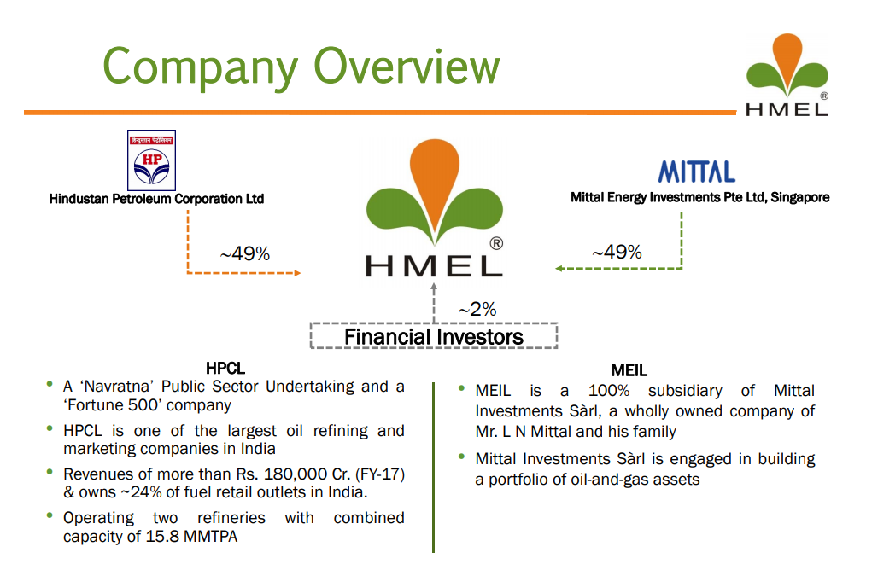

* **About HMEL**
  + HPCL-Mittal Energy Limited (HMEL) is a joint venture between **Hindustan Petroleum Corporation Limited (HPCL) and Mittal Energy Investment Pte. Ltd, Singapore**.
  + Both the JV partners hold a stake of 49% each in the company and the remaining 2% is held by financial institutions.
  + HPCL-Mittal Energy Ltd (HMEL) owns and operates the Guru Gobind Singh Refinery (GGSR) of **11.3 MMTPA capacity** at Bhatinda, Punjab.
  + HMEL’s wholly owned subsidiary, HPCL-Mittal Pipelines Limited (HMPL), **owns and operates a Single Point Mooring (SPM)** for receipt of Crude Oil, **Crude Oil Terminal (COT)** for storage of Crude Oil and **1017km cross country pipeline** for transportation of the crude from Mundra, Gujarat to the refinery at Bhatinda.
  + The enormity of the Guru Gobind Singh Refinery project makes it the **single largest investment in the state of Punjab**.
  + It is the **first oil and gas project** to be set up in the state.
  + The refinery produces eight liquid product and three solid products of **EURO-IV specifications** using world-class environment-friendly technologies.
  + The refinery is a zero bottom plant, with a very **high Nelson Complexity Index**.
  + HMEL’s guiding beacon are its six core values which have helped build an environment of trust, transparency and teamwork; growing from 25 employees in 2008 to present number of **over 2000 committed employees** with diverse experience from over 150 leading organizations from India and abroad working relentlessly towards our vision of being the best refining company in the world.
* **About JV Partners**
  + **Hindustan Petroleum Corporation Ltd.**
    - HPCL is a fortune 500 company. HPCL operates two major refineries, producing a wide variety of petroleum fuels and specialties.
    - One of these is situated in Mumbai (West Coast) of 7.5 Million Metric Tonnes per Annum (MMTPA) capacity and the other is situated in Visakhapatnam (East Coast) with a capacity of 8.3 Million Metric Tonnes Per Annum (MMTPA).
  + **Mittal Energy Investment Pte Ltd.**
    - Mittal Energy Investment Pte Ltd is a part of Arcelor Mittal Group owned by Mr. Lakshmi Niwas Mittal.
    - Mittal Investments Sarl (‘MITTAL’), a Luxembourg incorporated company, is ultimately beneficially owned by Mr. Lakshmi N. Mittal and family.
    - In 2007, MITTAL through its subsidiary - Mittal Energy Investments Pte Ltd, Singapore, became 49% shareholder in an upcoming 9-MMTPA Greenfield refinery at Bhatinda
* **Core Values of HMEL**

* + Company’s values define and measure it.
  + The core values of HMEL speak of their actions so ingrained to steer them towards success and at as a driving force behind the company’s infrastructure.
  + Their values are their philosophy and culture, helping to build a world-class Energy company.
  + They are governed by six core values:
    - **Safety First**
    - **Teamwork**
    - **Continuous Improvement and Learning**
    - **Respect for People**
    - **High Ethical Standards**
    - **Achieve Targets and Meet Deadlines**
* **About Guru Gobind Singh Refinery (GGSR)**

Guru Gobind Singh refinery is the single largest investment and the first oil and gas industry to be set up in the state of Punjab, India.

* + Operates on 11.3 MMTPA Crude processing Level
  + 1017 KM 28” and 30” diameter Crude Oil Pipeline from Mundra to Bhatinda.
  + Crude Oil Terminal at Mundra with a storage capacity of 8,40,000 KL
  + Single Point Mooring and 17Km 48” Diameter Offshore/ Onshore pipeline at Mundra.
  + Total plot area is 2300 acres* (Refinery Block: 1600 Acres; Water Block: 400 Acres; Green Belt Area: 307 Acres)
  + State of Art safety and environmental features with world class technology.
  + Flexibility to process a wide variety of crude oils including heavy, sour and other opportunity crudes.
  + High value added products, LPG, Naphtha, Petrol, Diesel, Aviation Fuel, Polypropylene, Hexane etc.
  + Diesel/ Petrol of Euro IV Quality.
  + Crude range of 26.5 – 32 de. API (American Petroleum Institute).
  + Capability to process high Sulfur Crudes up to 3% wt. “S”.
  + Capability to process high acidic crudes up to TANS 0.5 mg KOH/g.
  + High Nelson Complexity Index (10.7) for meeting indigenous demand.

# Overview

# Of

# Processes Involved

# In

# Crude Refining and Processing

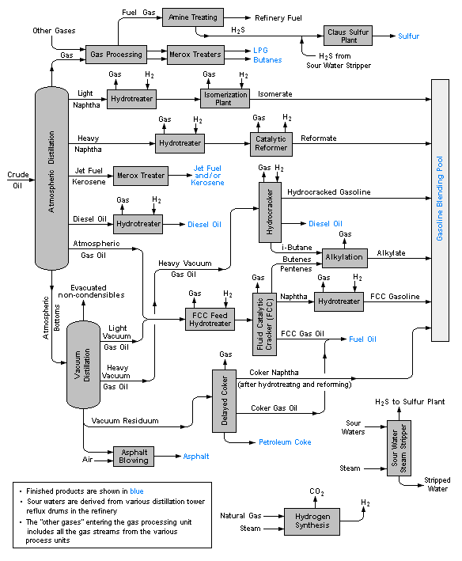

# Petroleum Refining Process: An Introduction

**Oil Refinery:**

An oil refinery is an industrial process plant where crude oil is processed and refined into more useful petroleum products like Liquefied Petroleum Gas (LPG), Petrol, Kerosene, Aviation Turbine Fuel, Diesel, etc.

Petroleum refining begins with distillation, or fractionation, of crude oils into separate hydrocarbon groups. The resultant products are directly related to the characteristics of the crude oil being processed. Most of these products of distillation are further converted into more usable products by changing their physical and molecular structures through cracking, reforming and other conversion processes.

These products are subsequently subjected to various treatment and separation processes such as extraction, hydro treating and sweetening in order to produce finished products. Whereas the simplest refineries are usually limited to atmospheric and vacuum distillation, integrated refineries incorporate fractionation, conversion, treatment, and blending with lubricant, heavy fuels, and asphalt manufacturing; they may also include petrochemical processing.

The numbers and types of different processes used in modern refineries depend primarily on the nature of crude feedstock and finished product requirements. Processes are also affected by economic factors including crude costs, product values, availability of utilities and transportation.

# Basic Refining Processes and Operations

Petroleum refining processes and operations can be classified into the following basic areas:

* **Separation**

Crude oil is physically separated by fractionation in atmospheric and vacuum distillation towers, into groups of hydrocarbon molecules with various boiling point ranges, called “fractions” or “cuts”.

* **Conversion**

Conversion processes used to change the size and/ or structure of hydrocarbon molecules include:

* + **Decomposition**: (Dividing) by Hydro, Thermal, and Catalytic Cracking and Coking.
  + **Unification**: (Combining) through Polymerization
  + **Alteration**: (Rearranging) with Isomerization and Catalytic Reforming
* **Treatment**

Since the beginning of refining, various treatment methods have been used to remove non-hydrocarbons, impurities and other constituents that adversely affect the performance properties of the finished products or reduce the efficiency of the conversion processes.

Treatment involves both chemical reactions and physical separation, such as dissolving, absorption or precipitation, using a variety and combination of processes. Treatment methods include removing and separating aromatics and naphthenes, as well as removing undesirable impurities and undesirable contaminants.

Sweetening compounds and acids are used to desulfurize crude oil before processing, and to treat products during and after processing.

Other treatment methods include crude desalting, chemical sweetening, acid treating, hydro-desulfurizing, solvent refining, caustic washing, hydro treating, dying, solvent extraction, and solvent de-waxing.

* **Formulating and Blending**

Formulating and blending is the process of mixing hydrocarbon fractions, additives and other components to produce finished products with specific desired performance properties.

* **Auxiliary Refining Operations**

Other refining operations which are required to support hydrocarbon processing include light ends recovery; sour water stripping; solid waste; waste water; and process water treatment and cooling; hydrogen production; sulfur recovery; and acid and tail gate treatment. Other process functions are providing catalysts, reagents, steam, air, nitrogen, oxygen, and hydrogen and fuel gases.

* **Refinery Non-Process Facilities**

All refineries have a multitude of facilities, functions, equipment and systems which support the hydrocarbon process operations. Typical support operations are heat and power generation; product movement; tank storage; shipping and handling; flares and relief systems; furnaces and heaters; alarms and sensors; and sampling, testing and inspecting. Non-process facilities include fire-fighting, water and protection systems, noise and pollution controls, laboratories, control rooms, warehouses, maintenance, and administrative facilities.

# Major Products and Crude Oil Refining

Petroleum refining has evolved continuously in response to changing consumer demand for better and different products. The original process requirement was to produce kerosene as a cheaper and better source of fuel for lighting than whale oil. The development of internal combustion engine led to the production of benzene, gasoline and diesel fuels. The evolution of airplanes created a need for high octane aviation gasoline and jet fuel, which is a sophisticated form of the original refinery product, kerosene. Present-day refineries produce a variety of products, including many which are used as cracking processes and lubricant manufacturing, and for the petrochemical industry. These products are broadly classified as fuels, petrochemical feedstock, solvents, process oils, lubricants, and special products such as wax, asphalt, and coke.

* **Fuels**

The principal fuel products are liquefied petroleum gas, gasoline, kerosene, jet fuel, diesel fuel, heating oil, and residual fuel oil.

* + **Liquefied Petroleum Gas (LPG)**

It consists of mixtures of paraffinic and olefinic hydrocarbons, such as propane and butane, is produced for use as a fuel, and is stored and handled as liquids under pressure. T is colorless, and the vapors are heavier than air and extremely flammable.

* + **Gasoline**

The most important refinery product is motor gasoline, a blend of relatively low-boiling hydrocarbon fractions, including reformate, alkylate, aliphatic naphtha (light straight-run naphtha), aromatic naphtha (thermal and catalytic cracked naphtha) and additives. The critical qualities for gasoline are octane number, volatility, and vapor pressure. Aviation gasoline is high-octane product, specially blended to perform well at high altitudes.

* + **Jet fuel and Kerosene**

Kerosene is a mixture of paraffins and naphthenes with usually less than 20% aromatics. It is used for lighting, heating, solvents and blending into diesel fuel. Jet fuel is middle distillate kerosene and is used in aircrafts.

* + **Distillate Fuels**

Diesel fuels and domestic heating oils are light-colored mixtures of paraffins, naphthenes and aromatics, and may contain moderate quantities of olefins. They are often hydro-desulfurized for improved stability. Distillate fuels are combustible and when heated may emit vapors which can form ignitable mixtures with air.

* + **Residual Fuels**

Many ships and commercial and industrial facilities use residual fuels or combinations of residual and distillate fuels, for power, heat and processing. Residual fuels are dark-colored and highly viscous liquid mixtures of large hydrocarbon molecules. The critical specifications for residual fuels are viscosity and low sulfur content.

* **Sour Water**

Sour water is process water which contains hydrogen sulfide, ammonia, phenols, hydrocarbons and low molecular-weight sulfur compounds. Sour water is produced by steam stripping hydrogen sulfide during hydro-treating and hydro-finishing. Sour water is also generated by addition of water to the process of absorbing hydrogen sulfide and ammonia.

* **Some Other Products**
  + Sulfur is produced as a result of petroleum refining. It is stored either as a heated, molten liquid in closed tanks or as solid in outdoor containers
  + Coke is almost pure carbon, with a variety of uses from electrodes to charcoal briquettes, depending on its physical characteristics, which result from the coking process.

# Overview

# Of

# Process Units

# In

# Petrochemical Refining

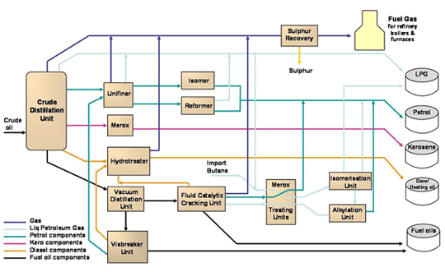

# CDU/ VDU Plant Details

* **Unit Objective**

To separate crude oil into different products by boiling point differences and prepare feed for secondary processing units.

* **Feed Input**
  + Crude Oil
* **Products**
  + LPG to LPG Treater
  + Stabilized Naphtha to NHT/ HGU/ HRU
  + Swing Naphtha to Naphtha Pool
  + Light Kerosene to ATF Merox/ Kero Pool/ DHDT
  + Heavy Kerosene to DHDT/ Kero Pool
  + Light and Heavy Gas Oils to DHDT
  + Light and Heavy Vacuum Gas Oils to VGO-HDT
  + Vacuum Reside to DCU

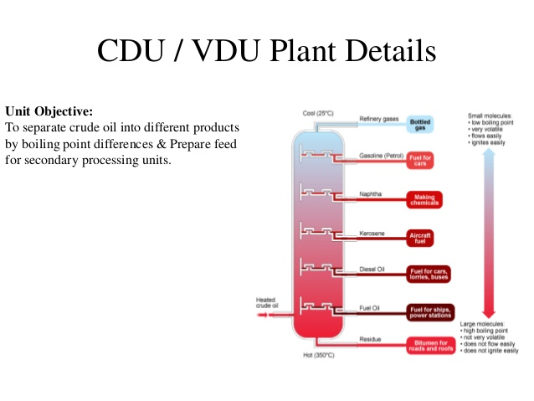

# Naphtha Hydro-Treating Unit Details

* **Unit Objective**

Naphtha Hydro-Treating Unit is used for the process of Hydro-Treating Naphtha Streams produced from Crude distillation and FCC and DHDT units to produce treated Naphtha containing less than 0.5 wt. ppm (parts per million) sulfur and less than 0.1 wt. ppm Nitrogen.

* **Feed Input**
  + Naphtha Streams from Crude Distillation, FCC, and DHDT
* **Products**
  + Light Naphtha to Isomerization units
  + Heavy Naphtha to CCR Unit Feed

# Naphtha Isomerization Unit Details

* **Unit Objective**

The objective of this unit is to increase the Research Octane Number (RON) of the Hydro-Treated Light Naphtha cut from NHDT in order to meet the required target of gasoline pool production.

Isomerate product is the blend of light and heavy isomerate from Deisohexaniser Column.

* **Example**

**CH3- CH2- CH2- CH2- CH2- CH3** (low octane no.) **🡪 CH3-C(CH3)2- CH2- CH3** (high octane no.)

* **Feed Input**
  + Hydro-Treated light Naphtha Cut from NHDT
* **Products**
  + Isomerate
  + An off gas stream sent to CCR Unit

# Continuous Catalytic Reformer Unit Details

* **Unit Objective**

The Continuous Catalytic Reformer units produces high octane aromatics from paraffins and naphthenes to be used as a High Octane Blending Component.

* **Reforming**

Reforming involves the conversion of low octane paraffinic &naphthenic compounds to aromatics

* **Feed Input**
  + Hydro-Treated Heavy Naphtha cut from NHDT
  + Off gas from Isomerization Unit
* **Products**
  + Reformate
  + LPG
  + Hydrogen

# Diesel Hydro-Treatment Unit Details

* **Unit Objective**

The primary objective is to maximize production of diesel to meet the Euro IV specifications.

* **Feed Input**
  + Mixture of LGO/ HGO/ Vacuum Diesel, LKO and HKO, Heavy Naphtha from CDU/ VDU
  + Coker Naphtha, LCGO from DCU
  + LCO from FCC Unit
  + DSO rich stream from the LPG treating Unit
* **Plant Details and Parts**
  + Heater
  + DHDT Reactor
  + Recycle Gas Compressor
  + HP Amine Absorber
  + Make-Up Gas Compressor
  + Naphtha Stabilization
  + Fractionator Column
* **Products**
  + Naphtha (10%) to NHT and Storage
  + Aviation Turbine Fuel/ MTO (6%) to Final Product Blending
  + Diesel (83%) to Final Product Blending

# Delayed Coking Unit (DCU) Details

* **Unit Objective**

Delayed Coking unit is used to convert low value residual products to lighter products of higher value and to produce a coke product.

* **Feed Input**
  + Vacuum Residue from VDU/ VR Tanks
  + VGO HDT Back Flush
  + FCCU Slurry Back Wash
  + Slop Oil from Tank
  + Crude Sludge for Crude Tanks
  + Sludge From ETP
  + Lean Amine
* **Salient Features**
  + Converts Vacuum Residue into fuel gas, LPG, Naphtha, Gas Oil, and Petroleum Coke
  + Satisfies Refinery FG (Fuel) Requirement
  + Converts Fuel Oil to other valued Products LPG, Naphtha, Coker Diesel, Coke in Refinery
  + No Catalyst Cost
  + Low Chemical/ Additive Cost
  + Coke as By-product For Power Plant/ Cement Plant
  + Coker can process Refinery Slops and Sludge
* **Products**
  + Fuel Gas to RFG Header
  + LPG to LPG Treating Unit
  + Rich Amine to ATU
  + LCGO+ Naphtha to DHT
  + Sour Water to SWS
  + HCGO to VGO HT
  + Petroleum Coke

# Vacuum Gas Oil Hydro-Treatment Unit Details

* **Unit Objective**

The primary objective of this unit is to produce Hydro-Treated Vacuum Gas Oil (VGO) having the desired level of Hydrogen, Low Sulfur, and low Nitrogen for the various design feed cases. The Hydro-Treated Vacuum Gas Oil (VGO) serves as the feedstock for the FCC (Petrochemical) Unit.

* **Feed Input**
  + Mixture of Straight Run Vacuum Gas Oil from CDU/ VDU and
  + HCGO from DCU unit
* **Licensor**
  + Axens
* **Detailed Engineering**
  + Engineers India Limited
* **Products**
  + Sweet Gas to PSA for H2
  + LPG to LPG Treating Units
  + Naphtha For Blending
  + Diesel to DHDT
  + Hydro-Treated VGO to FCC Unit

# Fluidized Catalytic Cracking Unit Details

* **Unit Objective**

The Fluidized Catalytic Cracking Unit Petrochemical Complex is a Deep Catalytic Cracking Unit. The main objective of the unit is to convert heavy hydrocarbon (Propane, Propylene, Butane, and Butylene etc.) products. It produces feeds to various units like PPU, MS Block & offsite.

* **Feed Input**
  + Mix of Straight Run Vacuum Gas Oil (VGO)
  + HCGO from CDU/ VDU and DCU
* **Licensor**
  + Stone and Webster
* **Detailed Engineering**
  + Engineers India Limited
* **Products**
  + Propylene to PPU
  + Fuel Gas to FG Treating Unit
  + LPG to LPG Treating Unit
  + LCN/ MCN Naphtha to MS Block
  + LCN/ MCN to MS Blending in off-sites

# Hydrogen Generation Unit (HGU) Details

* **Unit Objective**

The main objective of this unit is to Generate Hydrogen of High Purity required for Hydro-Processing the various units involved in the refinery such as NHT, DHDT, and VGO-HDT, ISOMER, PP and SRU TGT

* **Feed Input**
  + SR Naphtha from NSU
  + DHDT Naphtha from DHDT
* **Licensor**
  + Haldor Topsoe
* **Detailed Engineering**
  + L&T
* **Products**
  + Pure Hydrogen for DHDT, VGO HDT, PPU, SRU, NHT, HRU

# Polypropylene Unit (PPU) Details

* **Unit Objective**

The primary objective of the Polypropylene unit is to produce Polypropylene from propylene molecules.

* **Polypropylene**

Polypropylene is a long chain polymer made from propylene monomers. After exposing the propylene to both heat and pressure with an active catalyst, the propylene monomers combine to form a long chain polymer. Polypropylene is a thermoplastic polymer

* **Feed Input**
  + Propylene from Propylene Recovery Unit of FCCU
  + Propylene Mounted Bullets
* **Licensor**
  + Novolen
* **Detailed Engineering**
  + Engineers India Limited
* **Products**
  + Polypropylene Polymer
* **Uses of Polypropylene**
  + Fibers
  + Automobiles Plastic
  + Wires and Cables, etc.

# SR/ CR LPG Treating Plant Details

* **Unit Objective**

The primary objective of the unit is to remove H2S, Mercaptans and Carbonyl Sulfate (COS) from Straight Run LPG (SR LPG) and Cracked LPG (CR LPG) from CDU and DCU respectively

* **Feed Input**
  + SR LPG Treating Unit
    - SR LPG from CDU
    - SR LPG from Vacuum Gas Oil Hydro-Treatment
  + CR LPG Treating Unit
    - CR LPG from DCU
* **Products**
  + LPG
  + Auto – LPG

# Sulfur Recovery Unit (SRU) Details

Sulfur Recovery Unit (SRU) Block consists of the following units

* Sour Water Stripper – I and II
* Amine Regeneration Unit
* Sulfur Recovery Unit – I and II

Sour Water Stripper Unit Details

* **Unit Objective**

The primary objective of the unit is to process the Sour Water streams generated in the refinery process unit such as CDU/ VDU, DCU, Flare KOD, ARU, SRU-TGTU, HGU, and DCCU for Single Stage Stripper, Sour Water streams for Vacuum Gas Oil Hydro-Treatment and NHTU for Two Stage Stripper for the removal of H2S and NH3.

* **Licensor**
  + Engineers India Limited
* **Detailed Engineering**
  + Toyo Engineering India Ltd., Mumbai
* **Feed Input**
  + Sour Water Stripper 1 (SWS-I)
    - Sour water from CDU/ VDU
    - Sour water from DCU
    - Sour water from FLARE KOD
    - Sour water from ARU
    - Sour water from TGTU
    - Sour water from FFCU
  + Sour Water Stripper 2 (SWS-II)
    - Sour water from VGO HDT
    - Sour water from DHDT
    - Sour water from NHTU
* **Products**
  + Stripped Water to effluent treatment plant or water to CDU/ VDU, FCCU, DCU.
  + Stripped Water to effluent treatment plant or water to VGO HDT, DHDT, NHTU

Amine Regeneration Unit Details

* **Unit Objective**

The primary objective of the unit is to recover H2S from Rich Methyl Di-Ethanolamine streams received from Vacuum Gas Oil Hydro-Treater (VGO HDT) and Diesel Hydro-Treater (DHDT). Fuel Gas ATU, LPG ATU, and DCU.

* **Licensor**
  + Engineers India Limited
* **Detailed Engineering**
  + Toyo Engineering India Ltd., Mumbai
* **Feed Input**
  + Rich Methyl Di-Ethanolamine (MDEA) solution from Fuel Gas Treating Units, SR/ CR LPG treating Units, VGO HDT, DHDT, and DCU.
* **Products**
  + Lean Methyl Di-Ethanolamine (MDEA) to Refinery Units
  + Add H2S gas feed to Sulfur Recovery Unit – I and II

Sulfur Recovery Unit – I and II Details

* **Unit Objective**

Sulfur recovery refers to the conversion of hydrogen sulfide (H2S) to elemental sulfur.

Hydrogen sulfide is a by-product of processing natural gas and refining high-sulfur crude oils.

There are many sulfur recovery technologies available for different applications, however the most common conversion method used is the Claus process.

Approximately 90 to 95 percent of recovered sulfur is produced by the Claus process. The Claus process typically recovers 95 to 98 percent of the hydrogen sulfide feed-stream.

* **Licensor**
  + Porsenat
* **Detailed Engineering**
  + Toyo Engineering India Ltd., Mumbai
* **Feed Input**
  + Acid Gas (H2S) from Amine Regeneration Unit (ARU)
  + Sour Gas (H2S) from Sour Water Stripper Unit (SWS)
* **Products**
  + Elemental Sulfur

Captive Power Plant Details

* **Unit Objective**

The primary objective of the Captive Power Plant is to meet the total steam and power requirements of the Refinery Complex, besides the internal Requirements of the package.

* **Captive Power Plant Details**
  + 2 nos. Gas Turbine Generators (GTGs) along with Heat Recovery Steam Generators (HRSGs)
  + 3 nos. Steam Turbine Generators (STGs) – 2 Condensing Type and 1 Backpressure Type
  + 4 Nos. Utility Boilers (UBs) – 3W + 1S
  + Pressure Reducing De-Superheaters – For generating HP, MP, LP Steam
  + De-aerator and Condensate Storage Buffer Tank
  + CPP Cooling Tower
  + Chemical Dosing Systems
* **Total Power Generated**
  + 164 MW (including internal consumption of CPP)
* **Total Steam Generated**
  + 900 TPH of Steam
* **Feed/ Fuel**
  + FG, Light Cycle Oil (LCO), HSD for GTG’s and HRSG’s
  + FG, LCO for UB’s
  + DM Water from RO DM Plant

Condensate Polishing Unit Details

* **Unit Objective**

Condensate Polishing Unit (CPU) is a centralized facility for treating the suspect condensate in various process units, received from Refinery Complex, and meet the DM water quality parameters.

CPU Plant is an Integral Part of RO DM plant unit.

* **Major Steps Involved**
  + Feed Condense Cooling

Cooling of suspect condensate in a Heat exchanger to reduce the Condensate Temperature.

* + Adsorption

Removal of oil present in feed condensate by passing the condensate through an archived Carbon Bed

* + Mixed Bed Polishing

Mixed Bed unit has both Strong Acid Cation Resin and Strong Base Anion Resin mixed in a single vessel. Cations/ Anions are removed in Mixed Bed Exchanger in order to achieve the required quality of treated condensate.

* **Plant Capacity**
  + Three (3) Parallel and similar chains, each of net capacity of 75 m­3/ hr.
  + When two (2) chains are under operation and active, the third chain is left idle/ on standby for regeneration
* **Feed Input**
  + Suspect Condensate from Refinery Process Units

Reverse Osmosis/ Demineralization Plant Details

* **Unit Objective**

The Reverse Osmosis Demineralization (RO DM) plant is a centralized facility for producing de-mineralized (DM) water for the Refinery Complex. DM water is required for the following purposes:

* + Boiler Feed Water makeup for generation of Steam
  + Process Water for dilution of chemicals, washing etc.
* **Plant Details**
  + **Pre-Treatment Stage**

Cooling of suspect condensate in a Heat Exchanger to reduce Condensate temperature.